tmux 화면
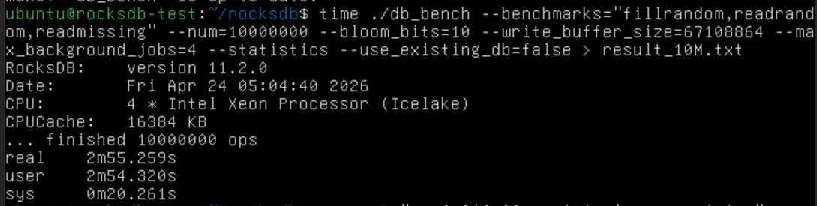
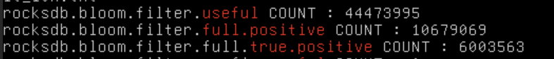

WinSCP 화면 (옆 부분은 개인정보라 짤랐어용)
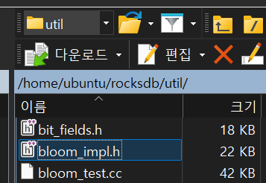

변경 부분
Bloom_impl.h
블룸 필터의 k 함수 수정 (// change 라고 주석 작성한 부분)

ChooseNumProbes 함수
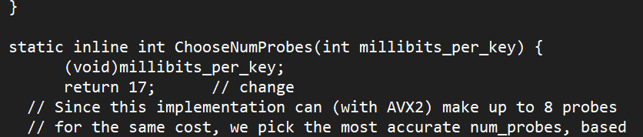

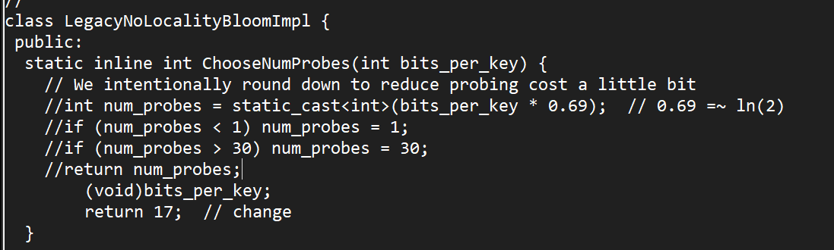

1. RocksDB의 기존 블룸 필터 최적화 로직 (수정 전)
RocksDB의 util/bloom_impl.h는 할당된 Bits/Key (m/n) 비율에 따라 가장 낮은 오차율(FPR)을 낼 수 있는 해시 함수 개수(k)를 동적으로 계산하거나 선택하도록 구현되어 있다.
Legacy 방식 (LegacyNoLocalityBloomImpl)
전통적인 블룸 필터의 수학적 이상치인 k = m/n * ln 2 (근사치) 공식을 따른다. 코드 상에서는 bits_per_key * 0.69를 연산하여 최적의 프로브(Probe) 횟수를 동적으로 도출한다.
최신 SIMD 최적화 방식 (FastLocalBloomImpl)
단순한 수학적 계산을 넘어, CPU의 캐시 라인(512 bits)과 AVX2 SIMD 명령어의 병렬 처리 효율을 극대화하기 위해 미리 튜닝된 k값을 사용한다. 내부적으로 if-else 분기문을 통해 $m/n$ 값의 구간마다 가장 효율적인 프로브 횟수를 매핑하여 반환하도록 설계되어 있다.2

실험을 위한 코드 수정 및 통제 변인 설정 (수정 후)
RocksDB가 내부적으로 k값을 자동 조절하는 가변적 최적화 로직을 비활성화하고, 실험자가 의도한 고정된 k값을 사용하도록 코드를 수정하였다.

참고용 전체 코드 (수정)

// Copyright (c) 2019-present, Facebook, Inc. All rights reserved.
// This source code is licensed under both the GPLv2 (found in the
// COPYING file in the root directory) and Apache 2.0 License
// (found in the LICENSE.Apache file in the root directory).
//
// Implementation details of various Bloom filter implementations used in
// RocksDB. (DynamicBloom is in a separate file for now because it
// supports concurrent write.)

#pragma once
#include <stddef.h>
#include <stdint.h>

#include <cmath>

#include "port/port.h" // for PREFETCH
#include "rocksdb/slice.h"
#include "util/hash.h"

#ifdef __AVX2__
#include <immintrin.h>
#endif

namespace ROCKSDB_NAMESPACE {

class BloomMath {
public:
// False positive rate of a standard Bloom filter, for given ratio of
// filter memory bits to added keys, and number of probes per operation.
// (The false positive rate is effectively independent of scale, assuming
// the implementation scales OK.)
static double StandardFpRate(double bits_per_key, int num_probes) {
// Standard very-good-estimate formula. See
// https://en.wikipedia.org/wiki/Bloom_filter#Probability_of_false_positives
return std::pow(1.0 - std::exp(-num_probes / bits_per_key), num_probes);
}

// False positive rate of a "blocked"/"shareded"/"cache-local" Bloom filter,
// for given ratio of filter memory bits to added keys, number of probes per
// operation (all within the given block or cache line size), and block or
// cache line size.
static double CacheLocalFpRate(double bits_per_key, int num_probes,
int cache_line_bits) {
if (bits_per_key <= 0.0) {
// Fix a discontinuity
return 1.0;
}
double keys_per_cache_line = cache_line_bits / bits_per_key;
// A reasonable estimate is the average of the FP rates for one standard
// deviation above and below the mean bucket occupancy. See
// https://github.com/facebook/rocksdb/wiki/RocksDB-Bloom-Filter#the-math
double keys_stddev = std::sqrt(keys_per_cache_line);
double crowded_fp = StandardFpRate(
cache_line_bits / (keys_per_cache_line + keys_stddev), num_probes);
double uncrowded_fp = StandardFpRate(
cache_line_bits / (keys_per_cache_line - keys_stddev), num_probes);
return (crowded_fp + uncrowded_fp) / 2;
}

// False positive rate of querying a new item against `num_keys` items, all
// hashed to `fingerprint_bits` bits. (This assumes the fingerprint hashes
// themselves are stored losslessly. See Section 4 of
// http://www.ccs.neu.edu/home/pete/pub/bloom-filters-verification.pdf)
static double FingerprintFpRate(size_t num_keys, int fingerprint_bits) {
double inv_fingerprint_space = std::pow(0.5, fingerprint_bits);
// Base estimate assumes each key maps to a unique fingerprint.
// Could be > 1 in extreme cases.
double base_estimate = num_keys * inv_fingerprint_space;
// To account for potential overlap, we choose between two formulas
if (base_estimate > 0.0001) {
// A very good formula assuming we don't construct a floating point
// number extremely close to 1. Always produces a probability < 1.
return 1.0 - std::exp(-base_estimate);
} else {
// A very good formula when base_estimate is far below 1. (Subtract
// away the integral-approximated sum that some key has same hash as
// one coming before it in a list.)
return base_estimate - (base_estimate * base_estimate * 0.5);
}
}

// Returns the probably of either of two independent(-ish) events
// happening, given their probabilities. (This is useful for combining
// results from StandardFpRate or CacheLocalFpRate with FingerprintFpRate
// for a hash-efficient Bloom filter's FP rate. See Section 4 of
// http://www.ccs.neu.edu/home/pete/pub/bloom-filters-verification.pdf)
static double IndependentProbabilitySum(double rate1, double rate2) {
// Use formula that avoids floating point extremely close to 1 if
// rates are extremely small.
return rate1 + rate2 - (rate1 * rate2);
}
};

// A fast, flexible, and accurate cache-local Bloom implementation with
// SIMD-optimized query performance (currently using AVX2 on Intel). Write
// performance and non-SIMD read are very good, benefiting from FastRange32
// used in place of % and single-cycle multiplication on recent processors.
//
// Most other SIMD Bloom implementations sacrifice flexibility and/or
// accuracy by requiring num_probes to be a power of two and restricting
// where each probe can occur in a cache line. This implementation sacrifices
// SIMD-optimization for add (might still be possible, especially with AVX512)
// in favor of allowing any num_probes, not crossing cache line boundary,
// and accuracy close to theoretical best accuracy for a cache-local Bloom.
// E.g. theoretical best for 10 bits/key, num_probes=6, and 512-bit bucket
// (Intel cache line size) is 0.9535% FP rate. This implementation yields
// about 0.957%. (Compare to LegacyLocalityBloomImpl<false> at 1.138%, or
// about 0.951% for 1024-bit buckets, cache line size for some ARM CPUs.)
//
// This implementation can use a 32-bit hash (let h2 be h1 * 0x9e3779b9) or
// a 64-bit hash (split into two uint32s). With many millions of keys, the
// false positive rate associated with using a 32-bit hash can dominate the
// false positive rate of the underlying filter. At 10 bits/key setting, the
// inflection point is about 40 million keys, so 32-bit hash is a bad idea
// with 10s of millions of keys or more.
//
// Despite accepting a 64-bit hash, this implementation uses 32-bit fastrange
// to pick a cache line, which can be faster than 64-bit in some cases.
// This only hurts accuracy as you get into 10s of GB for a single filter,
// and accuracy abruptly breaks down at 256GB (2^32 cache lines). Switch to
// 64-bit fastrange if you need filters so big. ;)
//
// Using only a 32-bit input hash within each cache line has negligible
// impact for any reasonable cache line / bucket size, for arbitrary filter
// size, and potentially saves intermediate data size in some cases vs.
// tracking full 64 bits. (Even in an implementation using 64-bit arithmetic
// to generate indices, I might do the same, as a single multiplication
// suffices to generate a sufficiently mixed 64 bits from 32 bits.)
//
// This implementation is currently tied to Intel cache line size, 64 bytes ==
// 512 bits. If there's sufficient demand for other cache line sizes, this is
// a pretty good implementation to extend, but slight performance enhancements
// are possible with an alternate implementation (probably not very compatible
// with SIMD):
// (1) Use rotation in addition to multiplication for remixing
// (like murmur hash). (Using multiplication alone *slightly* hurts accuracy
// because lower bits never depend on original upper bits.)
// (2) Extract more than one bit index from each re-mix. (Only if rotation
// or similar is part of remix, because otherwise you're making the
// multiplication-only problem worse.)
// (3) Re-mix full 64 bit hash, to get maximum number of bit indices per
// re-mix.
//
class FastLocalBloomImpl {
public:
// NOTE: this has only been validated to enough accuracy for producing
// reasonable warnings / user feedback, not for making functional decisions.
static double EstimatedFpRate(size_t keys, size_t bytes, int num_probes,
int hash_bits) {
return BloomMath::IndependentProbabilitySum(
BloomMath::CacheLocalFpRate(8.0 * bytes / keys, num_probes,
/*cache line bits*/ 512),
BloomMath::FingerprintFpRate(keys, hash_bits));
}

static inline int ChooseNumProbes(int millibits_per_key) {
(void)millibits_per_key;
return 17; // change
// Since this implementation can (with AVX2) make up to 8 probes
// for the same cost, we pick the most accurate num_probes, based
// on actual tests of the implementation. Note that for higher
// bits/key, the best choice for cache-local Bloom can be notably
// smaller than standard bloom, e.g. 9 instead of 11 @ 16 b/k.
if (millibits_per_key <= 2080) {
return 1;
} else if (millibits_per_key <= 3580) {
return 2;
} else if (millibits_per_key <= 5100) {
return 3;
} else if (millibits_per_key <= 6640) {
return 4;
} else if (millibits_per_key <= 8300) {
return 5;
} else if (millibits_per_key <= 10070) {
return 6;
} else if (millibits_per_key <= 11720) {
return 7;
} else if (millibits_per_key <= 14001) {
// Would be something like <= 13800 but sacrificing *slightly* for
// more settings using <= 8 probes.
return 8;
} else if (millibits_per_key <= 16050) {
return 9;
} else if (millibits_per_key <= 18300) {
return 10;
} else if (millibits_per_key <= 22001) {
return 11;
} else if (millibits_per_key <= 25501) {
return 12;
} else if (millibits_per_key > 50000) {
// Top out at 24 probes (three sets of 8)
return 24;
} else {
// Roughly optimal choices for remaining range
// e.g.
// 28000 -> 12, 28001 -> 13
// 50000 -> 23, 50001 -> 24
return (millibits_per_key - 1) / 2000 - 1;
}
}

static inline void AddHash(uint32_t h1, uint32_t h2, uint32_t len_bytes,
int num_probes, char* data) {
uint32_t bytes_to_cache_line = FastRange32(h1, len_bytes >> 6) << 6;
AddHashPrepared(h2, num_probes, data + bytes_to_cache_line);
}

static inline void AddHashPrepared(uint32_t h2, int num_probes,
char* data_at_cache_line) {
uint32_t h = h2;
for (int i = 0; i < num_probes; ++i, h *= uint32_t{0x9e3779b9}) {
// 9-bit address within 512 bit cache line
int bitpos = h >> (32 - 9);
data_at_cache_line[bitpos >> 3] |= (uint8_t{1} << (bitpos & 7));
}
}

static inline void PrepareHash(uint32_t h1, uint32_t len_bytes,
const char* data,
uint32_t /*out*/* byte_offset) {
uint32_t bytes_to_cache_line = FastRange32(h1, len_bytes >> 6) << 6;
PREFETCH(data + bytes_to_cache_line, 0 /* rw */, 1 /* locality */);
PREFETCH(data + bytes_to_cache_line + 63, 0 /* rw */, 1 /* locality */);
*byte_offset = bytes_to_cache_line;
}

static inline bool HashMayMatch(uint32_t h1, uint32_t h2, uint32_t len_bytes,
int num_probes, const char* data) {
uint32_t bytes_to_cache_line = FastRange32(h1, len_bytes >> 6) << 6;
return HashMayMatchPrepared(h2, num_probes, data + bytes_to_cache_line);
}

static inline bool HashMayMatchPrepared(uint32_t h2, int num_probes,
const char* data_at_cache_line) {
uint32_t h = h2;
#ifdef __AVX2__
int rem_probes = num_probes;

// NOTE: For better performance for num_probes in {1, 2, 9, 10, 17, 18,
// etc.} one can insert specialized code for rem_probes <= 2, bypassing
// the SIMD code in those cases. There is a detectable but minor overhead
// applied to other values of num_probes (when not statically determined),
// but smoother performance curve vs. num_probes. But for now, when
// in doubt, don't add unnecessary code.

// Powers of 32-bit golden ratio, mod 2**32.
const __m256i multipliers =
_mm256_setr_epi32(0x00000001, 0x9e3779b9, 0xe35e67b1, 0x734297e9,
0x35fbe861, 0xdeb7c719, 0x448b211, 0x3459b749);

for (;;) {
// Eight copies of hash
__m256i hash_vector = _mm256_set1_epi32(h);

// Same effect as repeated multiplication by 0x9e3779b9 thanks to
// associativity of multiplication.
hash_vector = _mm256_mullo_epi32(hash_vector, multipliers);

// Now the top 9 bits of each of the eight 32-bit values in
// hash_vector are bit addresses for probes within the cache line.
// While the platform-independent code uses byte addressing (6 bits
// to pick a byte + 3 bits to pick a bit within a byte), here we work
// with 32-bit words (4 bits to pick a word + 5 bits to pick a bit
// within a word) because that works well with AVX2 and is equivalent
// under little-endian.

// Shift each right by 28 bits to get 4-bit word addresses.
const __m256i word_addresses = _mm256_srli_epi32(hash_vector, 28);

// Gather 32-bit values spread over 512 bits by 4-bit address. In
// essence, we are dereferencing eight pointers within the cache
// line.
//
// Option 1: AVX2 gather (seems to be a little slow - understandable)
// const __m256i value_vector =
// _mm256_i32gather_epi32(static_cast<const int
// *>(data_at_cache_line),
// word_addresses,
// /*bytes / i32*/ 4);
// END Option 1
// Potentially unaligned as we're not *always* cache-aligned -> loadu
const __m256i* mm_data =
reinterpret_cast<const __m256i*>(data_at_cache_line);
__m256i lower = _mm256_loadu_si256(mm_data);
__m256i upper = _mm256_loadu_si256(mm_data + 1);
// Option 2: AVX512VL permute hack
// Only negligibly faster than Option 3, so not yet worth supporting
// const __m256i value_vector =
// _mm256_permutex2var_epi32(lower, word_addresses, upper);
// END Option 2
// Option 3: AVX2 permute+blend hack
// Use lowest three bits to order probing values, as if all from same
// 256 bit piece.
lower = _mm256_permutevar8x32_epi32(lower, word_addresses);
upper = _mm256_permutevar8x32_epi32(upper, word_addresses);
// Just top 1 bit of address, to select between lower and upper.
const __m256i upper_lower_selector = _mm256_srai_epi32(hash_vector, 31);
// Finally: the next 8 probed 32-bit values, in probing sequence order.
const __m256i value_vector =
_mm256_blendv_epi8(lower, upper, upper_lower_selector);
// END Option 3

// We might not need to probe all 8, so build a mask for selecting only
// what we need. (The k_selector(s) could be pre-computed but that
// doesn't seem to make a noticeable performance difference.)
const __m256i zero_to_seven = _mm256_setr_epi32(0, 1, 2, 3, 4, 5, 6, 7);
// Subtract rem_probes from each of those constants
__m256i k_selector =
_mm256_sub_epi32(zero_to_seven, _mm256_set1_epi32(rem_probes));
// Negative after subtract -> use/select
// Keep only high bit (logical shift right each by 31).
k_selector = _mm256_srli_epi32(k_selector, 31);

// Strip off the 4 bit word address (shift left)
__m256i bit_addresses = _mm256_slli_epi32(hash_vector, 4);
// And keep only 5-bit (32 - 27) bit-within-32-bit-word addresses.
bit_addresses = _mm256_srli_epi32(bit_addresses, 27);
// Build a bit mask
const __m256i bit_mask = _mm256_sllv_epi32(k_selector, bit_addresses);

// Like ((~value_vector) & bit_mask) == 0)
bool match = _mm256_testc_si256(value_vector, bit_mask) != 0;

// This check first so that it's easy for branch predictor to optimize
// num_probes <= 8 case, making it free of unpredictable branches.
if (rem_probes <= 8) {
return match;
} else if (!match) {
return false;
}
// otherwise
// Need another iteration. 0xab25f4c1 == golden ratio to the 8th power
h *= 0xab25f4c1;
rem_probes -= 8;
}
#else
for (int i = 0; i < num_probes; ++i, h *= uint32_t{0x9e3779b9}) {
// 9-bit address within 512 bit cache line
int bitpos = h >> (32 - 9);
if ((data_at_cache_line[bitpos >> 3] & (char(1) << (bitpos & 7))) == 0) {
return false;
}
}
return true;
#endif
}
};

// A legacy Bloom filter implementation with no locality of probes (slow).
// It uses double hashing to generate a sequence of hash values.
// Asymptotic analysis is in [Kirsch,Mitzenmacher 2006], but known to have
// subtle accuracy flaws for practical sizes [Dillinger,Manolios 2004].
//
// DO NOT REUSE
//
class LegacyNoLocalityBloomImpl {
public:
static inline int ChooseNumProbes(int bits_per_key) {
// We intentionally round down to reduce probing cost a little bit
//int num_probes = static_cast<int>(bits_per_key * 0.69); // 0.69 =~ ln(2)
//if (num_probes < 1) num_probes = 1;
//if (num_probes > 30) num_probes = 30;
//return num_probes;
(void)bits_per_key;
return 17; // change
}

static inline void AddHash(uint32_t h, uint32_t total_bits, int num_probes,
char* data) {
const uint32_t delta = (h >> 17) | (h << 15); // Rotate right 17 bits
for (int i = 0; i < num_probes; i++) {
const uint32_t bitpos = h % total_bits;
data[bitpos / 8] |= (1 << (bitpos % 8));
h += delta;
}
}

static inline bool HashMayMatch(uint32_t h, uint32_t total_bits,
int num_probes, const char* data) {
const uint32_t delta = (h >> 17) | (h << 15); // Rotate right 17 bits
for (int i = 0; i < num_probes; i++) {
const uint32_t bitpos = h % total_bits;
if ((data[bitpos / 8] & (1 << (bitpos % 8))) == 0) {
return false;
}
h += delta;
}
return true;
}
};

// A legacy Bloom filter implementation with probes local to a single
// cache line (fast). Because SST files might be transported between
// platforms, the cache line size is a parameter rather than hard coded.
// (But if specified as a constant parameter, an optimizing compiler
// should take advantage of that.)
//
// When ExtraRotates is false, this implementation is notably deficient in
// accuracy. Specifically, it uses double hashing with a 1/512 chance of the
// increment being zero (when cache line size is 512 bits). Thus, there's a
// 1/512 chance of probing only one index, which we'd expect to incur about
// a 1/2 * 1/512 or absolute 0.1% FP rate penalty. More detail at
// https://github.com/facebook/rocksdb/issues/4120
//
// DO NOT REUSE
//
template <bool ExtraRotates>
class LegacyLocalityBloomImpl {
private:
static inline uint32_t GetLine(uint32_t h, uint32_t num_lines) {
uint32_t offset_h = ExtraRotates ? (h >> 11) | (h << 21) : h;
return offset_h % num_lines;
}

public:
// NOTE: this has only been validated to enough accuracy for producing
// reasonable warnings / user feedback, not for making functional decisions.
static double EstimatedFpRate(size_t keys, size_t bytes, int num_probes) {
double bits_per_key = 8.0 * bytes / keys;
double filter_rate = BloomMath::CacheLocalFpRate(bits_per_key, num_probes,
/*cache line bits*/ 512);
if (!ExtraRotates) {
// Good estimate of impact of flaw in index computation.
// Adds roughly 0.002 around 50 bits/key and 0.001 around 100 bits/key.
// The + 22 shifts it nicely to fit for lower bits/key.
filter_rate += 0.1 / (bits_per_key * 0.75 + 22);
} else {
// Not yet validated
assert(false);
}
// Always uses 32-bit hash
double fingerprint_rate = BloomMath::FingerprintFpRate(keys, 32);
return BloomMath::IndependentProbabilitySum(filter_rate, fingerprint_rate);
}

static inline void AddHash(uint32_t h, uint32_t num_lines, int num_probes,
char* data, int log2_cache_line_bytes) {
const int log2_cache_line_bits = log2_cache_line_bytes + 3;

char* data_at_offset =
data + (GetLine(h, num_lines) << log2_cache_line_bytes);
const uint32_t delta = (h >> 17) | (h << 15);
for (int i = 0; i < num_probes; ++i) {
// Mask to bit-within-cache-line address
const uint32_t bitpos = h & ((1 << log2_cache_line_bits) - 1);
data_at_offset[bitpos / 8] |= (1 << (bitpos % 8));
if (ExtraRotates) {
h = (h >> log2_cache_line_bits) | (h << (32 - log2_cache_line_bits));
}
h += delta;
}
}

static inline void PrepareHashMayMatch(uint32_t h, uint32_t num_lines,
const char* data,
uint32_t /*out*/* byte_offset,
int log2_cache_line_bytes) {
uint32_t b = GetLine(h, num_lines) << log2_cache_line_bytes;
PREFETCH(data + b, 0 /* rw */, 1 /* locality */);
PREFETCH(data + b + ((1 << log2_cache_line_bytes) - 1), 0 /* rw */,
1 /* locality */);
*byte_offset = b;
}

static inline bool HashMayMatch(uint32_t h, uint32_t num_lines,
int num_probes, const char* data,
int log2_cache_line_bytes) {
uint32_t b = GetLine(h, num_lines) << log2_cache_line_bytes;
return HashMayMatchPrepared(h, num_probes, data + b, log2_cache_line_bytes);
}

static inline bool HashMayMatchPrepared(uint32_t h, int num_probes,
const char* data_at_offset,
int log2_cache_line_bytes) {
const int log2_cache_line_bits = log2_cache_line_bytes + 3;

const uint32_t delta = (h >> 17) | (h << 15);
for (int i = 0; i < num_probes; ++i) {
// Mask to bit-within-cache-line address
const uint32_t bitpos = h & ((1 << log2_cache_line_bits) - 1);
if (((data_at_offset[bitpos / 8]) & (1 << (bitpos % 8))) == 0) {
return false;
}
if (ExtraRotates) {
h = (h >> log2_cache_line_bits) | (h << (32 - log2_cache_line_bits));
}
h += delta;
}
return true;
}
};

} // namespace ROCKSDB_NAMESPACE

